Relative Readmission Risk Monitor (R3M)

**Background**

R3M is an application designed to assist post-discharge care coordinators in prioritizing their ACO patient load most effectively with the goal of reducing unplanned 30 day readmissions. To accomplish this, the application presents the care coordinator with a risk ranked list of the cohort of ACO patients that have been discharged to home within the previous 30 days.

The approach to ranking the patients on relative risk is based on predicting the hazard function of each of patients within the 30 day cohort. This hazard function mathematically describes the likelihood of readmission for each day between the patient’s discharge, and the end of the 30 day period relative to the day they were discharged.

The most critical component of the application is a statistical learning algorithm known as a *Random Survival Forest* used for the prediction of a patient’s hazard function based on information known about that patient. The algorithm is *trained* using a set of cases with known outcomes, and tested for accuracy using another set of cases with known outcomes. Once tuned for maximum performance, the algorithm is used to predict the hazard function of each newly discharged patient shortly after they leave the hospital. As more known outcome (*closed loop*) cases become available, the model can be periodically retrained to increase its accuracy over time.

Inputs to the model, known as features include information such as:

* Patient’s diagnostic, procedure history represented as a directed graph which is collated from several years of CMS claims data.
* A measure of the patient’s medication compliance based on prescription refill behavior.
* Specific medical information from the patient’s EMR record for the current inpatient encounter.
* Socioeconomic information from the US Census Bureau based on the patient’s home location.
* Driving distance to PCP office.
* Demographics such as age and age.

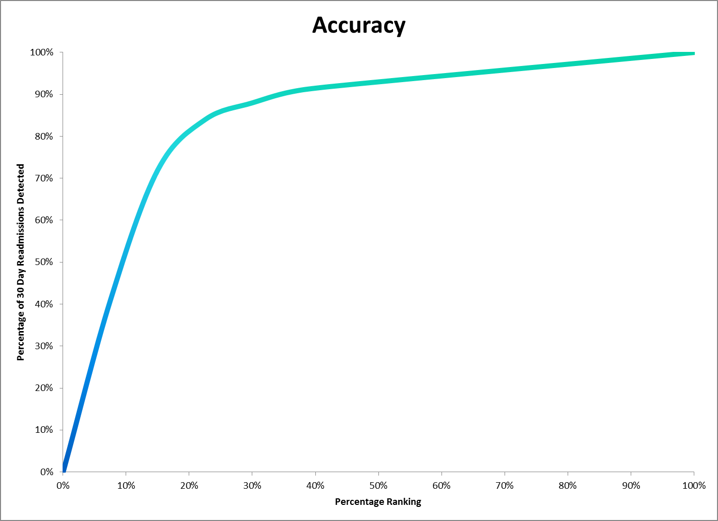

**Performance**

Accuracy can be measured by determining the percentage of 30 day readmissions that are accounted for by a given percent risk ranking. On average, 15% of patients discharged to home are readmitted within 30 days. The top 15% of the risk ranked list accounts for 72% of those readmissions, while the top 30% accounts for 88% of those readmitted. These performance statistics were calculated using 90 days of actual patient discharges.